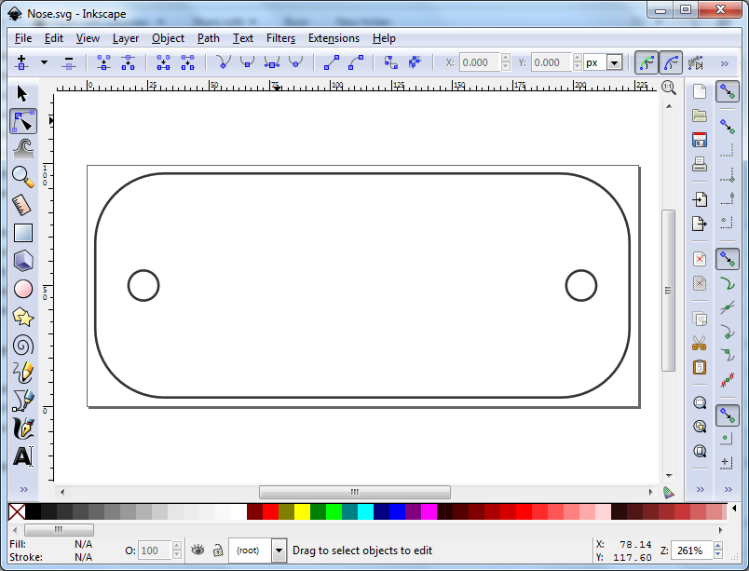  Launch Inskcape application.  Open File “Blank_badge.svg” file. | 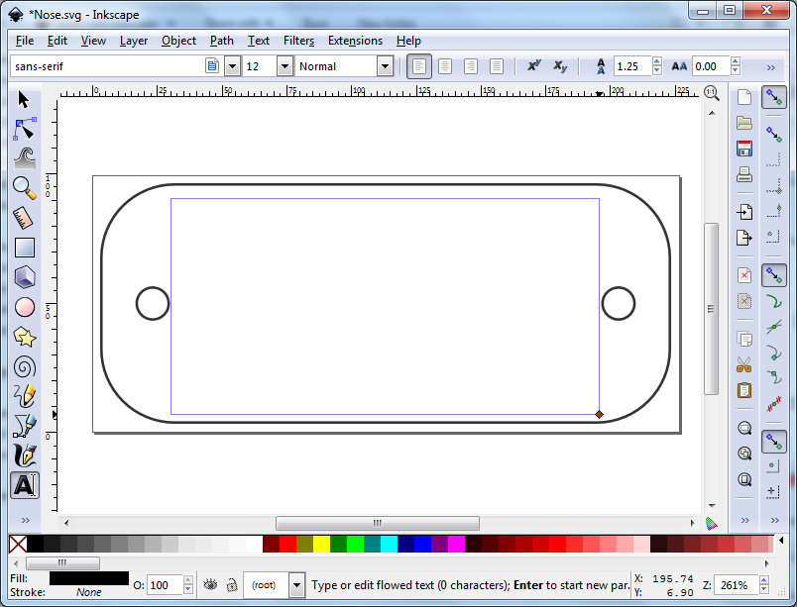  Click the “A” icon (“Create and Edit Text”) on the left pannel and use your mouse to crate a text area within the badge area.
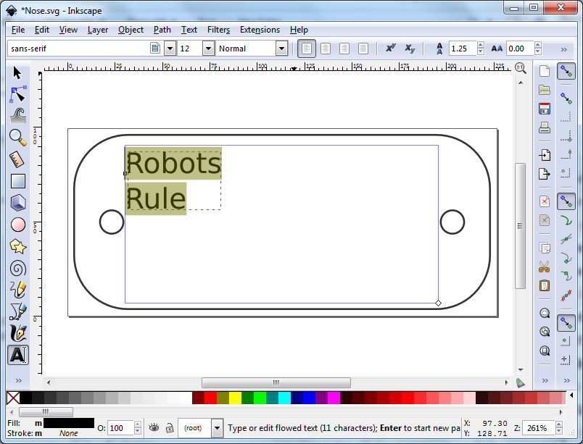  Type your text in the area. | 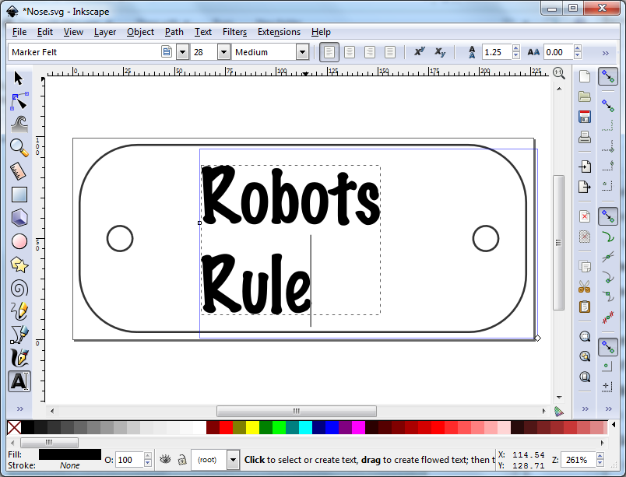  Select the text with your mouse and then pick the Font and Size you want.
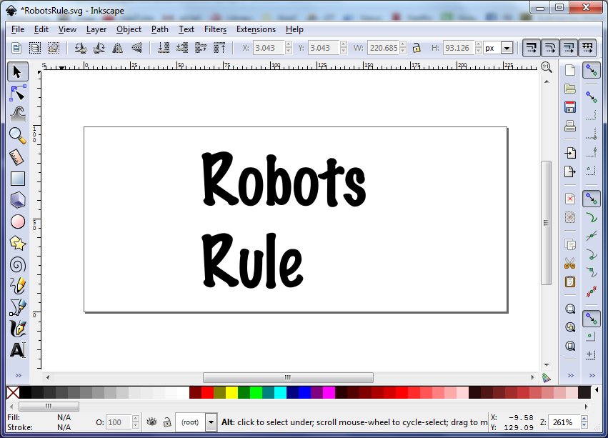  Select the original badge outline and click delete. “delete”. | 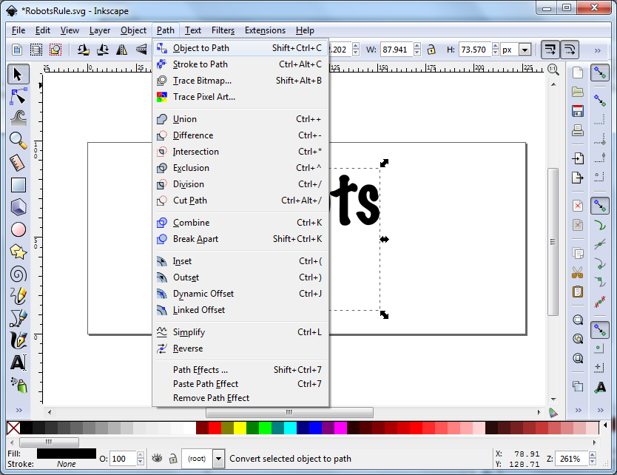  Click on the text box again and select “Path” → “Object to Path”.
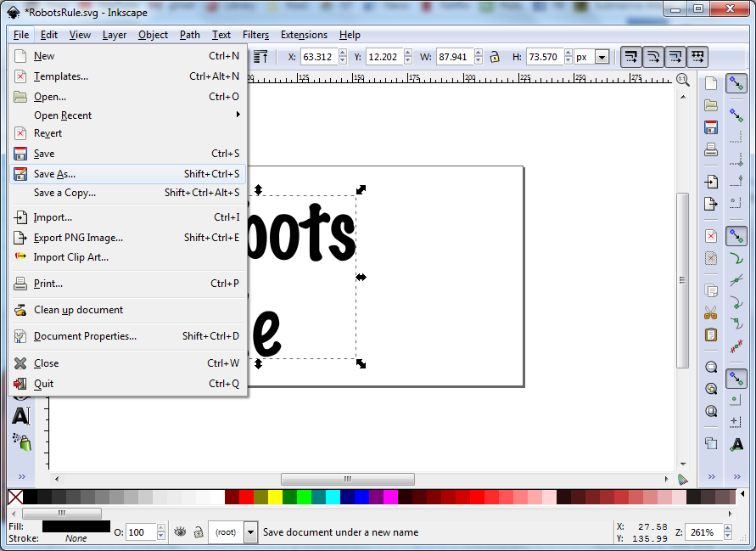  Select [File] → [Save As] → Select a unique SVG file name. | 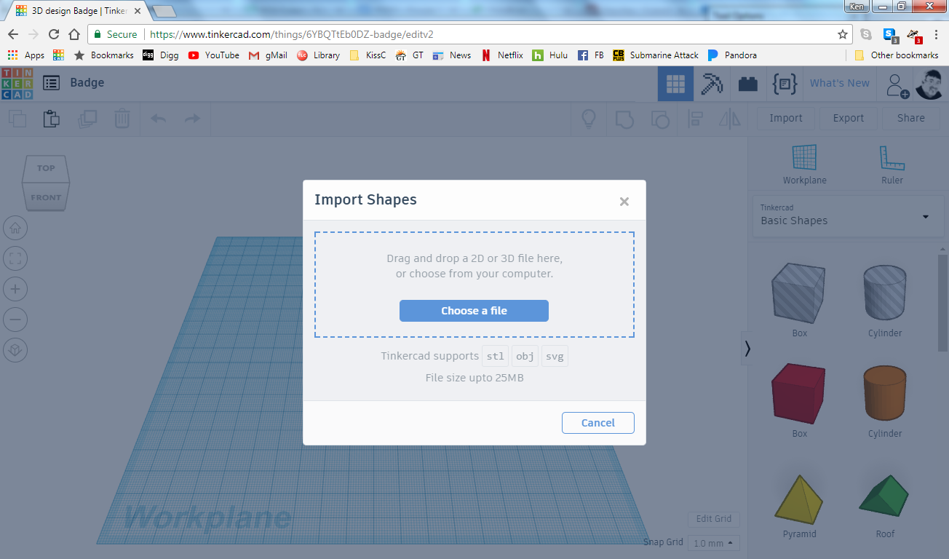  In TinkerCad.com, start a new project.  Select [Import] →”Blank_Badge.stl”.
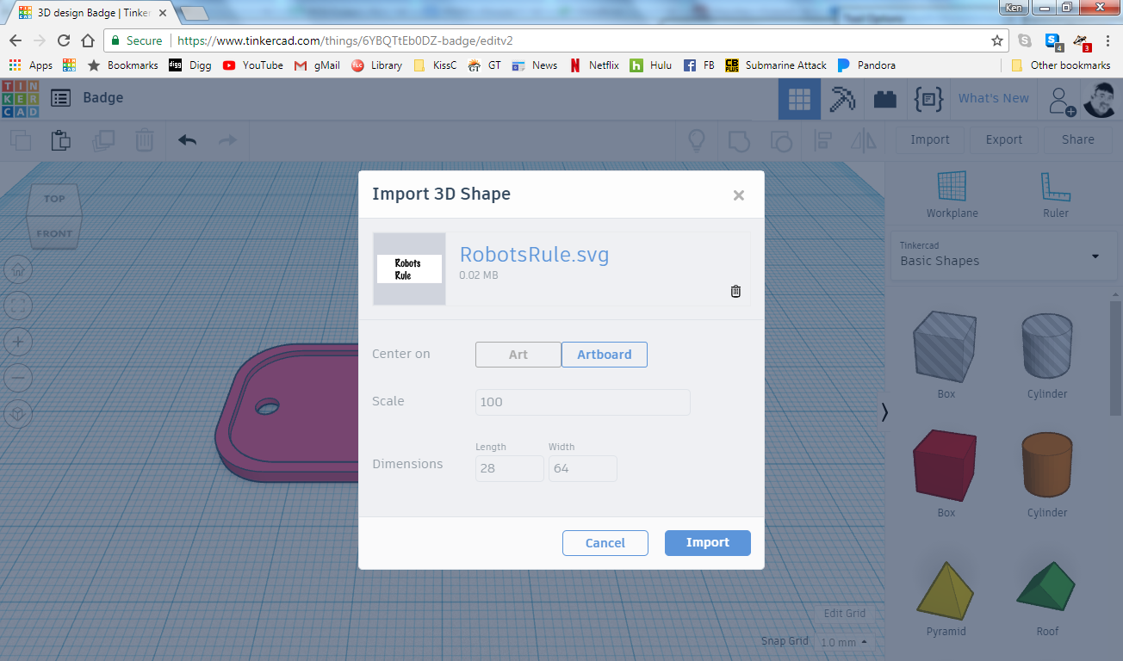  Select [Import] → Unique svg file you saved earlier. | 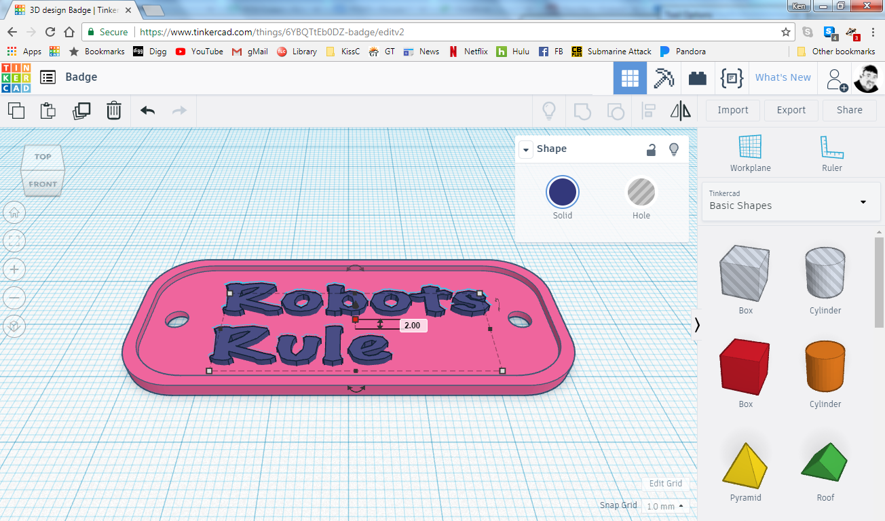  Repostion and resize text to fit inside of the badge shape.  Make the text size 2mm tall.
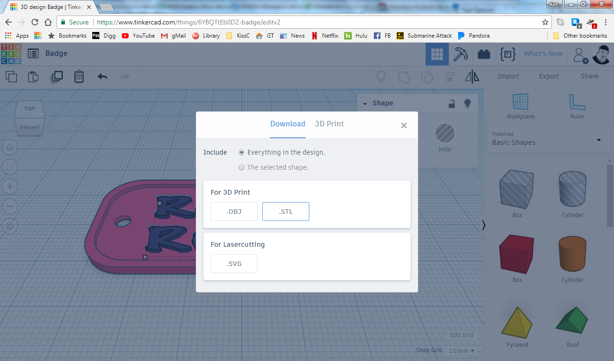  Select [Export].  Ensure “Everything in Design” is checked.  Click “STL” button. | 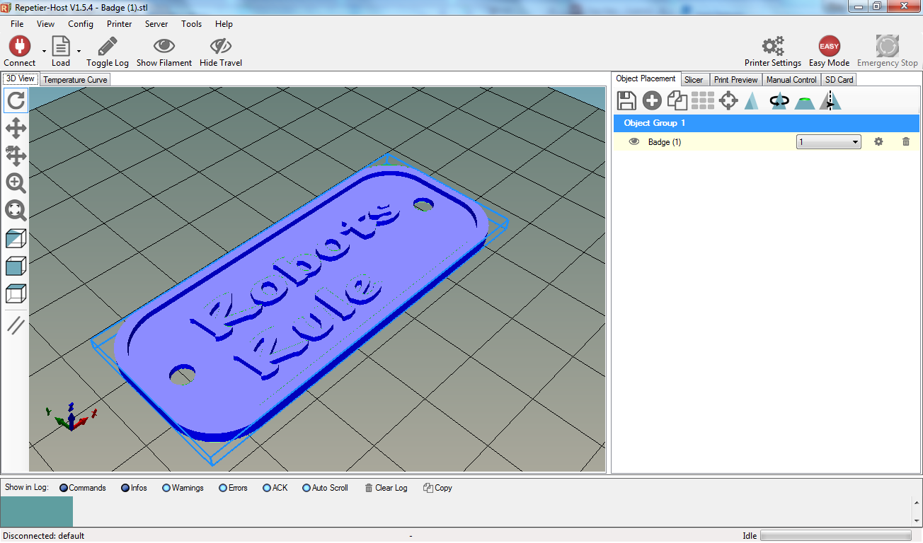  Open downloaded STL file in your slicer software to verify you are getting what you wanted!

